吳柏勳

航太四A | 407430635

MATLAB於工程最佳化的應用

期中報告

#1

Source code:

|  |  |
| --- | --- |
| 1 | clear;clc;close all |
| 2 | % Parameter define |
| 3 | R = 10; |
| 4 | V = 10:5:30; |
| 5 |  |
| 6 | % Calculate the power |
| 7 | P = ElectricPower(V, R); |
| 8 |  |
| 9 | % Plot the figure |
| 10 | figure() |
| 11 | plot(V, P, '.', 'MarkerSize', 12) |
| 12 |  |
| 13 | title("Power vs Voltage @ 10Ω") |
| 14 | xlabel("Voltage"); ylabel("Power") |
| 15 | xticks(V) |
| 16 | grid on |
| 17 |  |
| 18 | function P = ElectricPower(V, R) |
| 19 | % Description: |
| 20 | % Calculate the electric power with |
| 21 | % given voltage and resistance. |
| 22 | % |
| 23 | % Input argument: |
| 24 | % - V: Voltage(Volt, V) |
| 25 | % - R: Resistance(Ohm, Ω) |
| 26 | % |
| 27 | % Output argument: |
| 28 | % - P: Power(Watt, W) |
| 29 |  |
| 30 | P = (V.^2)./R; |
| 31 | end |

Program result:

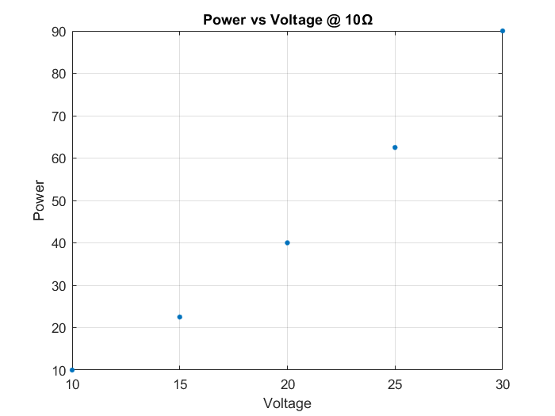

#2

Source code:

|  |  |
| --- | --- |
| 1 | clear;clc;close all |
| 2 | % Parameter define |
| 3 | x = linspace(-2*pi, 2*pi, 100); |
| 4 |  |
| 5 | % Calculate the curve value |
| 6 | y1 = sin(x); |
| 7 | y2 = cos(x); |
| 8 |  |
| 9 | % Plot the figure |
| 10 | figure(); hold on |
| 11 | plot(x, y1, 'LineWidth', 1) |
| 12 | plot(x, y2, 'LineWidth', 1) |
| 13 |  |
| 14 | title("Wave curve") |
| 15 | legend('y1', 'y2') |
| 16 | xlim([-2*pi 2*pi]); ylim([-1.1 1.1]) |
| 17 | xticks(-2*pi:pi:2*pi); yticks(-1:0.5:1) |
| 18 | xticklabels({'-2\pi','\pi','0','\pi','2\pi'} |
| 19 | xlabel('x'); ylabel('y') |
| 20 | grid on |

Program result:

